PROJECT REPORT OF CO-OP Project at Industry (Module-2)
ON
<Influence of Student Club Participation on Academic Performance and Student Development>
submitted in partial fulfilment of the requirements for the award of degree of

BACHELOR OF ENGINEERING
In
COMPUTER SCIENCE AND ENGINEERING

Submitted by: Supervised By:
Ishika - 2210990421 Dr. Manav Bansal
Daksh - 2210991470 Chief Happiness Officer
Chitkara Happiness Centre


DEPARTMENT OF COMPUTER SCIENCE AND ENGINEERING

CHITKARA UNIVERSITY INSTITUTE OF ENGINEERING AND TECHNOLOGY
CHITKARA UNIVERSITY, PUNJAB, INDIA

CONTENTS

S. No. | Title | Page No.
 | Acknowledgement | iv
 | List of Figures and Tables | v
 | Abstract | vi
1 | Introduction | 7
2 | Methodology | 8
3 | Tools and Technologies | 10
4 | Implementation | 10
5 | Major Findings/Outcomes/Output/Results | 11
6 | Conclusion and Future Scope | 14
 | References | 15
 | Appendices | 15

DECLARATION

I hereby certify that the work which is being presented in the project report entitled “Influence of Student Club Participation on Academic Performance and Student Development” in partial fulfilment of requirement for the award of the degree of Bachelor of Engineering (Computer Science and Engineering) submitted in the department of Computer Science and Engineering at Chitkara University Institute of Engineering and Technology, Chitkara University, Punjab, India, is an authentic record of my own work carried out under the supervision of Dr. Manav Bansal The matter presented in this project report has not been submitted in any other university/institute for the award of any degree.

Place : Rajpura Ishika - 2210990421
Date : 8th May 2026 Daksh - 2210991470

This is to certify that the above statement made by the candidate is correct to the best of my knowledge and belief.

Dr. Simar Virk
Associate Professor
Department of Computer Science and Engineering
Chitkara University Institute of Engineering and Technology,
Chitkara University, Punjab, India

ACKNOWLEDGEMENT

We would like to express our sincere gratitude to the Office of Student Life, Chitkara University, for their continuous support and guidance throughout the completion of this research work. Their encouragement and cooperation played an important role in the successful execution of this study.

We are also thankful to all the students who participated in the survey and provided their valuable responses. Their participation made this research possible and contributed significantly to the collection of meaningful data and insights.

Finally, we would like to thank our faculty members and peers for their suggestions and motivation during the research process.

LIST OF FIGURES AND TABLES

Figures
- Fig. 1: Google Form
- Fig 2: Responses of Google Form
- Fig. 3: Participation Distribution among Students
- Fig. 4: Academic Performance Distribution (CGPA)
- Fig 5: Average Skill Development Scores among Students

ABSTRACT

Student engagement beyond classroom learning has become an important component of modern higher education. Universities increasingly focus on holistic development by encouraging participation in extracurricular activities such as student clubs. This study examines the influence of student club participation on academic performance and overall student development at Chitkara University.

Primary data for the study were collected through a structured questionnaire distributed among undergraduate students. The respondents were categorized into two groups: students actively participating in clubs and students not involved in extracurricular activities. The research evaluates key variables including academic performance, confidence levels, communication skills, teamwork, and time management.

The findings of the study indicate that student club participation positively contributes to personal and professional development. Students involved in club activities demonstrated higher confidence levels, better communication abilities, stronger teamwork skills, and improved time management. The analysis also revealed that participation in extracurricular activities does not negatively affect academic performance. A significant number of students maintained high academic achievement while actively engaging in student clubs.

The study emphasizes the importance of structured student engagement initiatives within universities. It concludes that balanced participation in academic and extracurricular activities contributes significantly to holistic student development and overall productivity.

1. INTRODUCTION

In recent years, higher education institutions have broadened their focus from academic success to the holistic development of students. Universities now emphasize experiential learning, leadership development, and interpersonal skill enhancement as essential aspects of student growth. This shift reflects the increasing need for students to develop both academic knowledge and practical skills required in professional environments.

Student clubs have emerged as an effective platform for encouraging student engagement beyond classroom learning. These clubs provide opportunities for students to participate in cultural, technical, leadership, sports, and social activities. Through such involvement, students interact with peers, explore their interests, and develop important skills such as communication, teamwork, leadership, and time management.

At Chitkara University, the Office of Student Life plays an important role in organizing and supporting various student clubs and activities. These clubs create opportunities for students to actively participate in university life and gain exposure to practical learning experiences.
Despite the recognized advantages of extracurricular activities, there remains an ongoing debate regarding their impact on academic performance. Some educators and students believe that involvement in clubs enhances motivation, productivity, and personal growth. Others argue that excessive participation in extracurricular activities may distract students from academics and negatively affect academic achievement.

The present study aims to examine the influence of student club participation on academic performance and overall student development. The research compares students who actively participate in clubs with those who do not engage in extracurricular activities. The study focuses on variables such as academic performance, confidence levels, communication skills, teamwork, and time management.

By using a data-driven approach, this research seeks to provide a better understanding of the role of student clubs in supporting both academic success and personal development among university students.

2. METHODOLOGY

2.1 Research Design

The study adopts a quantitative research design using a survey-based approach to collect and analyse data. The research focuses on examining the relationship between student club participation and academic as well as personal development outcomes.

2.2 Data Collection

Primary data for the study were collected using a structured questionnaire created through Google Forms. The questionnaire was distributed among undergraduate students of Chitkara University across different departments and academic years.
The questionnaire consisted of multiple-choice questions and Likert scale-based statements designed to measure academic performance, student engagement, communication skills, teamwork, confidence, and time management abilities.

2.3 Sample Size

A total of 111 valid responses were collected from undergraduate students. The respondents included students from different departments and years of study, ensuring diversity within the dataset.

2.4 Sampling Technique

The study used a convenience sampling technique for collecting responses. Participants were selected based on accessibility and willingness to participate in the survey.

2.5 Variables Considered

The research focused on the following variables:
- Academic Performance (CGPA)
- Confidence Levels
- Communication Skills
- Teamwork
- Time Management

2.6 Tools for Analysis

The collected data were analysed using Microsoft Excel. Descriptive statistical techniques such as percentage analysis and comparative analysis were used to interpret the responses. Graphical representations including pie charts and bar graphs were also used for data visualization.

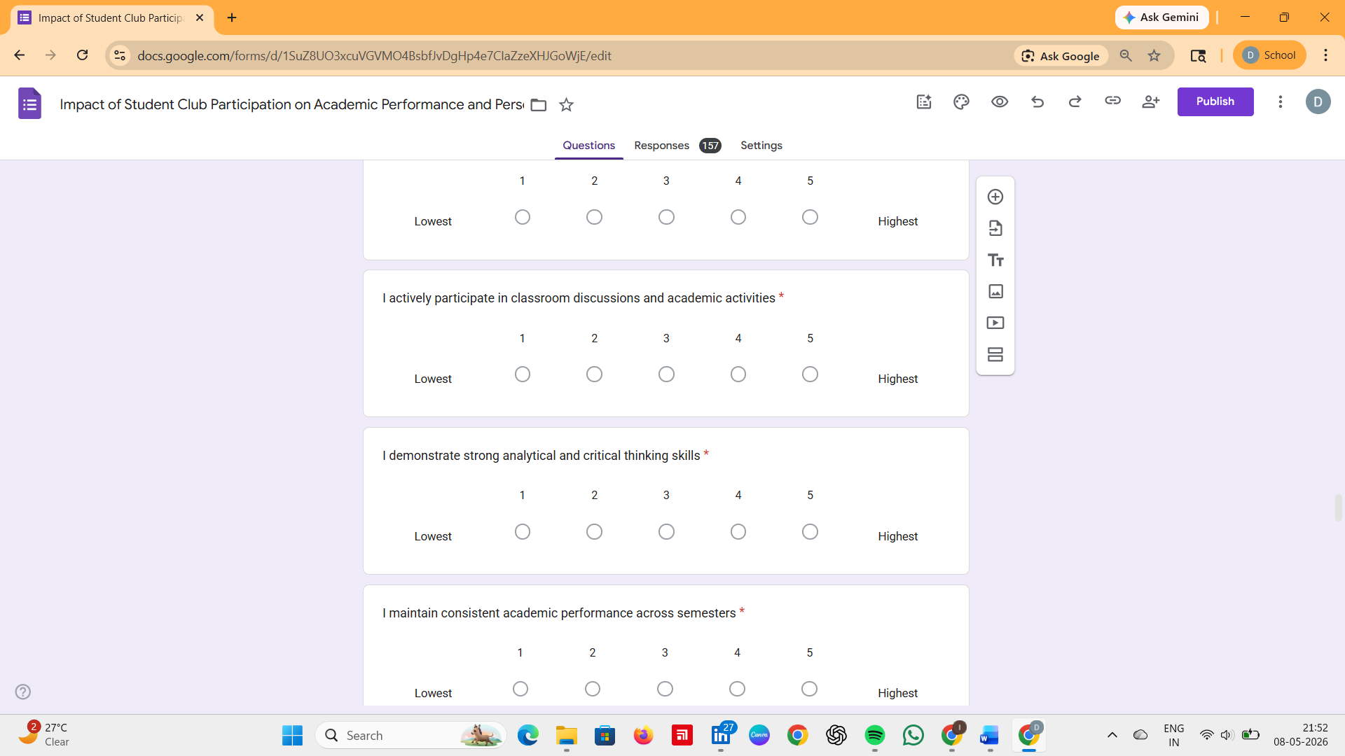
Figure 1 – Google Form

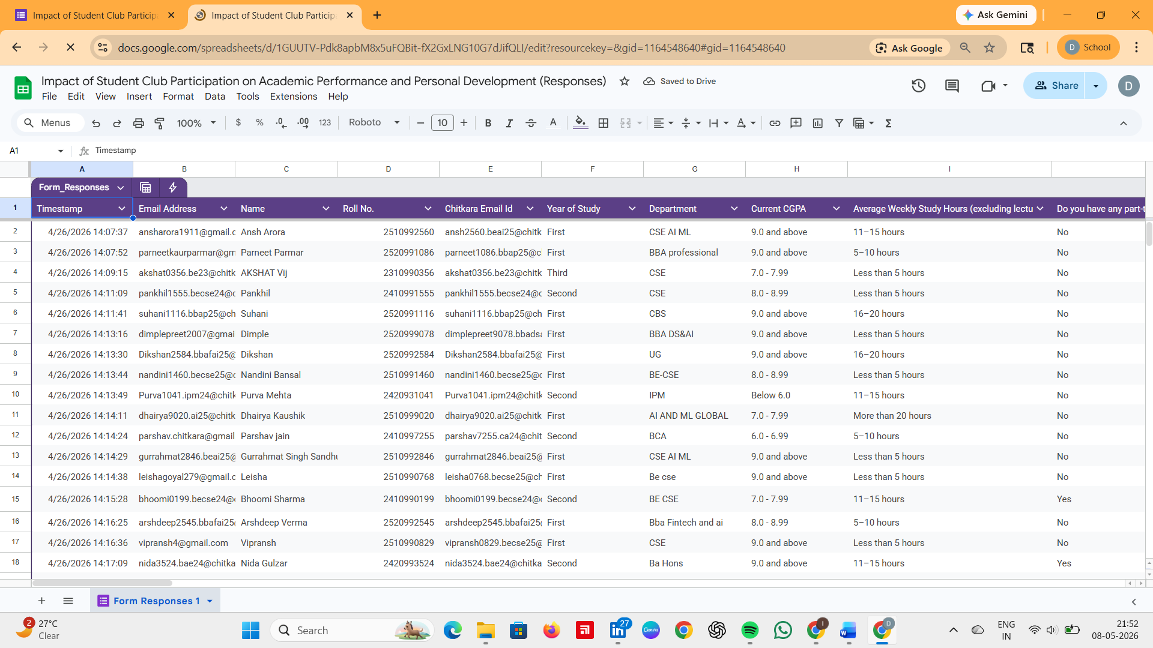
Figure 2 – Responses of Google Form

3. TOOLS AND TECHNOLOGIES

Several tools and technologies were used during the execution of this research project.
Google Forms - Google Forms was used to design and distribute the questionnaire among students. It helped in collecting responses efficiently and organizing the data systematically.
Microsoft Excel - Microsoft Excel was used for data cleaning, analysis, percentage calculations, and graph generation. Excel also assisted in creating visual representations such as pie charts and bar graphs.
IEEE Format - The IEEE format was used for structuring and documenting the research paper. It provided a professional and standardized format for presenting the study.
Graphical Visualization Tools - Charts and graphical representations were used to simplify data interpretation and present findings clearly.

4. IMPLEMENTATION

The implementation phase involved the design, distribution, and analysis of the survey questionnaire.
Initially, a structured questionnaire was prepared based on the objectives of the study. The questionnaire included sections related to demographic details, student club participation, academic performance, communication skills, confidence levels, teamwork, and time management.
Special attention was given to categorizing respondents into club participants and non-participants to enable comparative analysis. Google Forms was used as the primary platform for collecting responses.
After distributing the questionnaire among undergraduate students, a total of 111 responses were collected. The responses were then exported into Microsoft Excel for further analysis.
Data cleaning and organization were performed before conducting percentage analysis and comparative analysis. Charts and graphs were generated to visually represent participation trends, academic performance distribution, and skill development indicators.
The collected findings were interpreted systematically to understand the influence of student club participation on overall student development.

5. MAJOR FINDINGS / RESULTS

5.1 Participation Overview

The survey revealed that approximately 87.4% of respondents actively participate in student clubs, while 12.6% reported no involvement in extracurricular activities. This indicates a strong culture of student engagement within the university.
5.2 Academic Performance

The analysis showed that student club participation does not negatively affect academic performance. Approximately 45.9% of respondents reported a CGPA of 9.0 and above, while 29.7% were within the 8.0–8.99 range.
The findings suggest that students are capable of balancing academics and extracurricular activities effectively.
5.3 Confidence Levels

Students involved in club activities demonstrated higher confidence levels. The average confidence score among respondents was approximately 4.2 out of 5. Participation in events, leadership opportunities, and public speaking activities contributed significantly to self-confidence.
5.4 Communication Skills

Communication skills showed considerable improvement among club participants. The average communication score was approximately 4.3 out of 5. Students reported better interaction, presentation, and discussion abilities due to regular participation in collaborative activities.
5.5 Teamwork and Collaboration

The study revealed that students actively participating in clubs exhibited strong teamwork abilities. The average teamwork score was 4.4 out of 5, indicating significant improvement in coordination and collaboration skills.
5.6 Time Management

Students participating in extracurricular activities reported improved time management abilities. The average score for time management was 4.1 out of 5. The findings suggest that club involvement encourages better planning and productivity.
Overall, the results indicate that student club participation contributes positively to personal and professional development without adversely affecting academic performance.

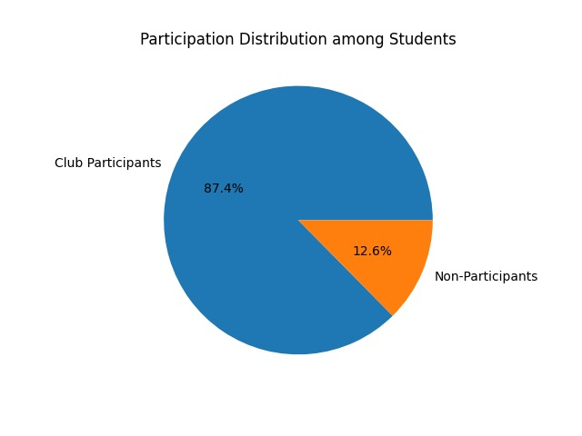
Figure 3 – Pie Chart Participation Distribution 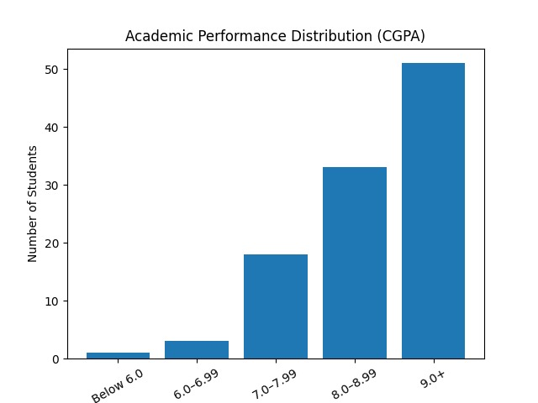Figure 4 – Graph of CGPA 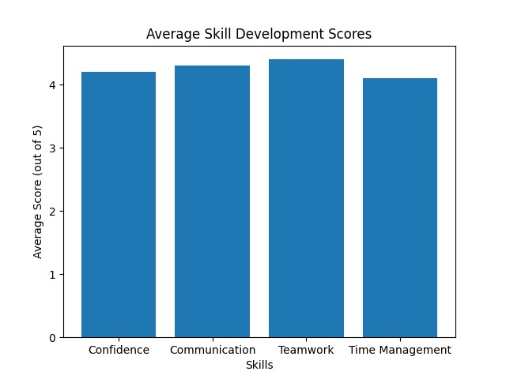
Figure 5 – Bar Graph of Skill Development

6. CONCLUSION AND FUTURE SCOPE

The study concludes that student club participation positively influences both academic performance and overall student development. The findings demonstrate that students are able to maintain strong academic achievement while actively participating in extracurricular activities.
Participation in student clubs contributes significantly to the development of important skills such as communication, confidence, teamwork, leadership, and time management. These skills are essential for academic growth as well as future professional success.
The research highlights the importance of structured student engagement initiatives within universities. Institutional support through platforms such as the Office of Student Life plays a major role in encouraging student participation and holistic development.

Future Scope

Future studies may expand the scope of research by including multiple universities and a larger sample size. Advanced statistical tools and analytical techniques can also be used to provide deeper insights into the relationship between student engagement and academic performance.
Further research may focus on examining the long-term impact of student club participation on career growth, employability, and professional success.

REFERENCES
[1] A. W. Astin, “Student Involvement: A Developmental Theory for Higher Education,” Journal of College Student Development, vol. 25, no. 4, pp. 297–308, 1984.
[2] G. D. Kuh, “High-Impact Educational Practices: What They Are, Who Has Access to Them, and Why They Matter,” Association of American Colleges and Universities, Washington, DC, USA, 2008.
[3] F. J. Baker, “The Impact of Extracurricular Activities on Student Development,” Journal of Education Research, vol. 45, no. 2, pp. 123–130, 2015.
[4] R. W. Larson, “Toward a Psychology of Positive Youth Development,” American Psychologist, vol. 55, no. 1, pp. 170–183, 2000.

APPENDICES
Appendix A: Survey Questionnaire
The questionnaire included sections related to:
- Demographic information
- Club participation status
- Academic performance indicators
- Confidence and communication skills
- Teamwork and collaboration
- Time management abilities
Appendix B: Graphical Representations
- Participation Distribution Chart
- Academic Performance Bar Graph
- Skill Development Analysis Graph

